🡨 PROJECT REPORT🡪

---

Task Management Project Overview

1. Introduction

This project is a web-based \*\*Task Management System\*\* designed to help users easily organize and track their tasks. The goal is to offer a simple yet effective tool that allows users to manage their daily activities seamlessly. The frontend uses \*\*React\*\* for a dynamic, user-friendly interface, while the backend is powered by \*\*Spring Boot\*\*, handling all the data and logic in the background.

2. Purpose of the Project

- Provide an easy-to-use platform for users to manage their tasks.

- Help users keep track of task progress and deadlines.

- Allow for secure user authentication with a login system.

- Let users add, delete, and update tasks quickly.

- Ensure the design is responsive, so it works well on any device.

---

3. Technology Used

-Frontend: React.js, HTML, CSS, JavaScript

- Backend: Spring Boot and Java

- Database: MySQL or H2 (for development purposes)

- Security: Spring Security for user login and authentication

- Additional Tools: Postman (API testing), Git, Maven

---

4. Key Features

1. User Authentication:

- A Login Page where users can securely log in with their credentials (email and password). After logging in, they’re directed to their personal task management workspace.

2. Task Management :

- Users can create tasks by providing a title, description, and deadline.

- They can mark tasks as complete or in-progress.

- Tasks can be edited or deleted as needed.

- Tasks can be filtered by their status or due date.

3. Activity Logs:

- Every task action, like creating or completing tasks, is recorded in an activity log.

- This helps users track changes and see their progress over time.

4. Responsive Design:

- The app works smoothly on all devices, whether it’s a phone, tablet, or desktop.

---

5. System Overview

- Frontend (React):

- The frontend interacts with the backend through RESTful APIs.

- Users are given an intuitive interface to manage tasks and activities.

- Backend (Spring Boot):

- The backend processes the business logic, handles user authentication, and connects to the database.

- APIs are provided for tasks, user info, and activity logs.

---

6. User Interface

6.1 Login Page

The login page is simple and secure. Users enter their credentials to access the task management area.

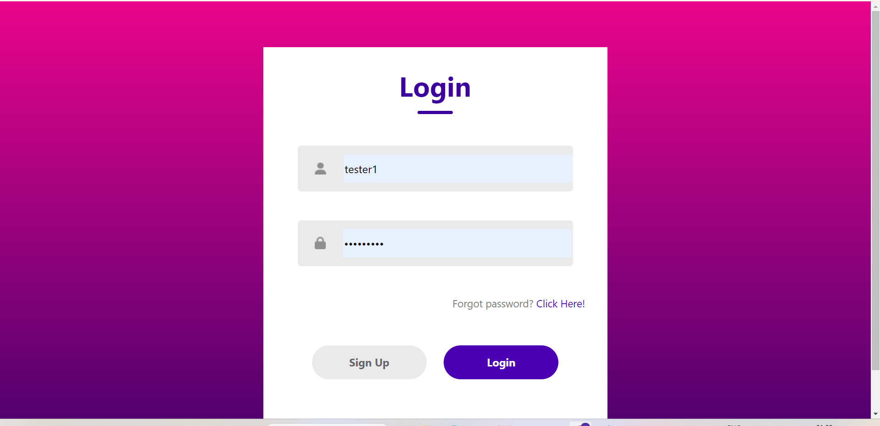

6.2 Task Management Workspace

Once logged in, users can see their tasks in a clean, organized layout. They can easily add new tasks, edit existing ones, or delete them.

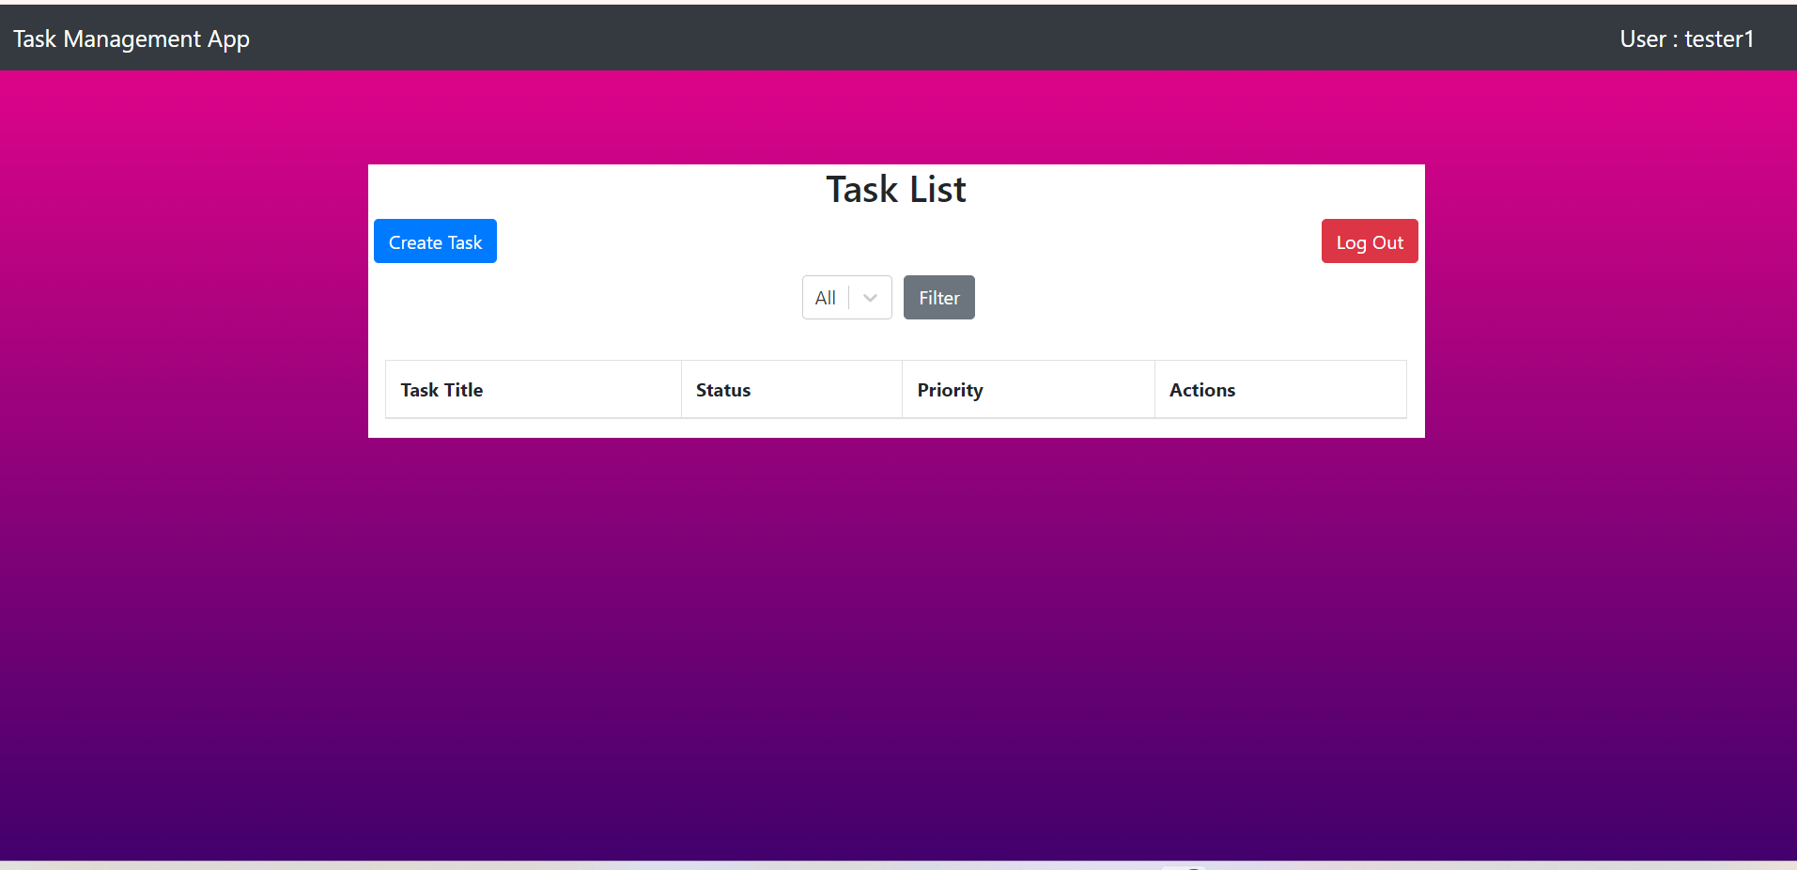

---

7. Main Features

7.1 Adding a Task

Users can add new tasks by filling in details like:

- Task Title

- Task Description

- Deadline

- (Optional) Priority Level

The task will then show up on their list, and they can track it until completion.

7.2 Activity Logs

Each task action—whether it’s creating, updating, or completing tasks—is logged. This gives users a clear view of what’s been done over time.

---

8. Security

We’ve implemented Spring Security to ensure that only authorized users can access their task data. Users need to log in with their credentials, which are securely checked against the database. Unauthorized users won’t be able to access any data.

---

9. Final Thoughts

This Task Management System provides an efficient and easy-to-use platform to help users manage their day-to-day activities. With a responsive React frontend and a robust Spring Boot backend, this project ensures that users can organize their tasks effectively, no matter where they are.

---